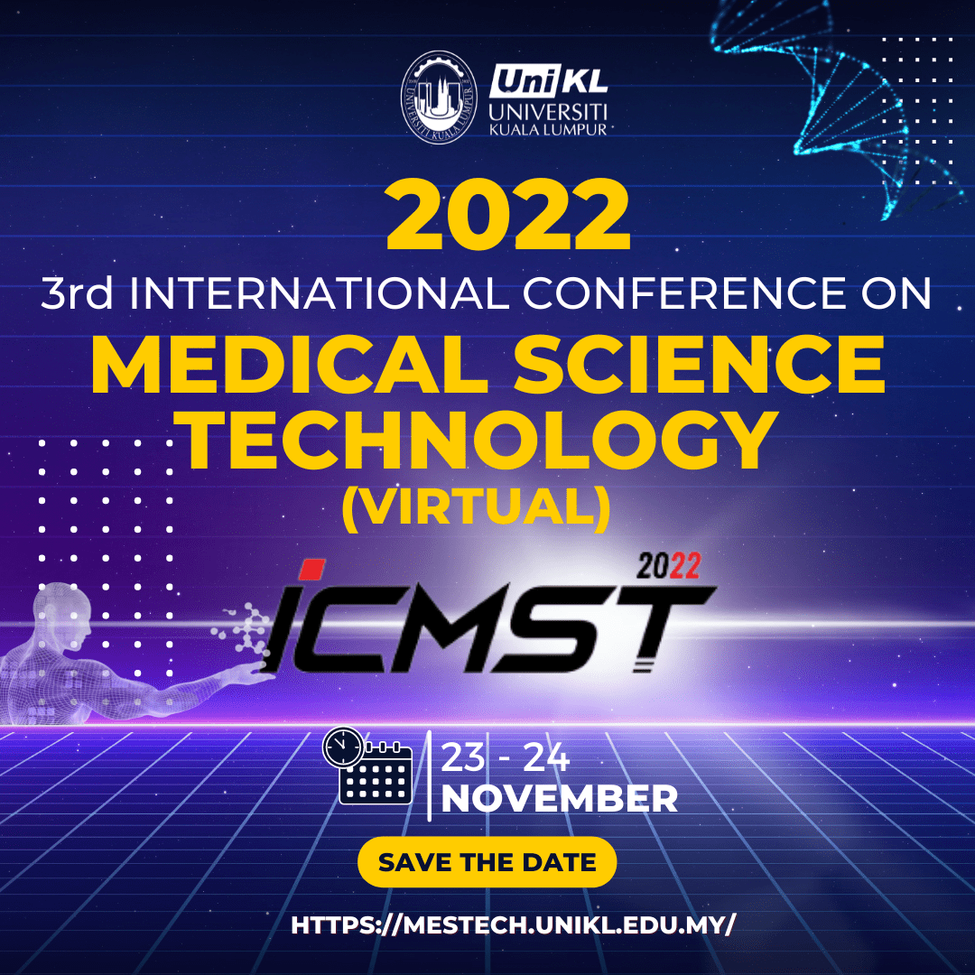

Abstract Submission Form
Abstract No. [For Office use]

For more than one author, please copy and paste the following eight rows for each additional author.
Title | Prof Dr Mr Ms Other Specify:
First Name
Family Name
Position
University/Organization
(Full address)
Country
E-mail
Phone(s)/Fax
Category/theme  (Please refer to the Conference website for the categories details) | Biomedical Science Clinical Laboratory Diagnostic  Public Health Bioengineering & Healthcare Technology

Abstract
Please type your abstract within the borders of the frame with Font Calibri Size 11pt.
(not more than 250 words)
Title Of Paper

Surname INITIALS¹*, Surname INITIALS¹, and Surname INITIALS²
¹Department, Faculty, University, Country
²Department, Institute, Country

*author@xxxxx.xx (*Corresponding author’s email)

Background/ Aims:

Methodology:

Results:

Conclusion:

Keywords: maximum 6 words

What is your preference for presentation? | Oral ( Pre-recorded video)  E-Poster (Pre-recorded video)

